CSA4705-Deep Learning for Game Theory
Name: L Dattu Kumar
Reg No:192124141

Experiment 1:
Aim: To demonstrate confusion matrix using python
Program:
import numpy as np
from sklearn.metrics import confusion_matrix
import seaborn as sns
import matplotlib.pyplot as plt
actual = np.array(
['Dog','Dog','Dog','Not Dog','Dog','Not Dog','Dog','Dog','Not Dog','Not Dog'])
predicted = np.array(
['Dog','Not Dog','Dog','Not Dog','Dog','Dog','Dog','Dog','Not Dog','Not Dog'])
conf_matrix=confusion_matrix(actual,predicted)
sns.heatmap(conf_matrix,annot=True,fmt='g',xticklabels=['Dog','Not Dog'],yticklabels=['Dog','Not Dog'],cmap='RdPu')
plt.ylabel("prediction",fontsize=16)
plt.xlabel("actual",fontsize=16)
plt.title("confusion matrix",fontsize=20)
plt.show()

Output:
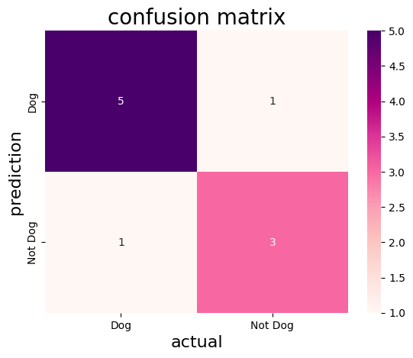

Experiment 2:
Aim: To demonstrate 2 class confusion matrix using python
Program:
import pandas as pd
import matplotlib.pyplot as plt
import seaborn as sns
from sklearn.datasets import load_wine
from sklearn.model_selection import train_test_split
from sklearn.tree import DecisionTreeClassifier
from sklearn.metrics import accuracy_score,f1_score,precision_score,recall_score,classification_report,confusion_matrix
wine=load_wine()
data=pd.DataFrame(data=wine.data,columns=wine.feature_names)
data['Target']=wine.target
data=data[data['Target']!=2]
x=data.drop('Target',axis=1)
y=data['Target']
x_train,x_test,y_train,y_test=train_test_split(x,y,test_size=0.3,random_state=1)
model=DecisionTreeClassifier(random_state=1)
model.fit(x_train,y_train)
y_pred=model.predict(x_test)
accuracy=accuracy_score(y_test,y_pred)
print("accuracy:",accuracy)
class_report = classification_report(y_test, y_pred, target_names=wine.target_names[:2])
print("Classification Report:\n", class_report)
precision = precision_score(y_test, y_pred)
recall = recall_score(y_test, y_pred)
f1 = f1_score(y_test, y_pred)
print(f"Precision: {precision:.2f}")
print(f"Recall: {recall:.2f}")
print(f"F1 Score: {f1:.2f}")
conf_matrix=confusion_matrix(y_test,y_pred)
plt.figure(figsize=(8,6))
sns.heatmap(conf_matrix,annot=True,fmt='d',cmap='PuBuGn',xticklabels=wine.target_names[:2],yticklabels=wine.target_names[:2])
plt.xlabel("predicted label")
plt.ylabel("true label")
plt.title("confusion matrix")
plt.show()

Output:
accuracy: 0.9743589743589743
Classification Report:
precision recall f1-score support

class_0 1.00 0.94 0.97 17
class_1 0.96 1.00 0.98 22

accuracy 0.97 39
macro avg 0.98 0.97 0.97 39
weighted avg 0.98 0.97 0.97 39

Precision: 0.96
Recall: 1.00
F1 Score: 0.98
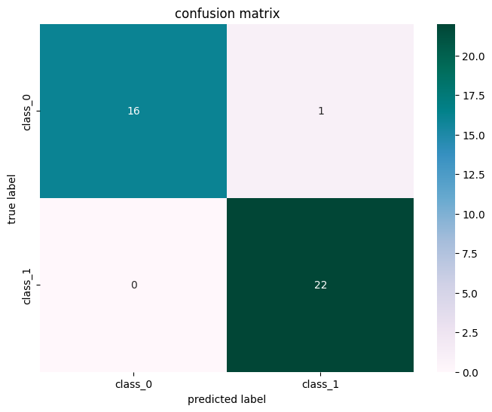

Experiment 3:
Aim: To analyse the performance of a multi class confusion matrix by using choosen database with python code
Program:
from sklearn.datasets import load_digits
from sklearn.model_selection import train_test_split
from sklearn.ensemble import RandomForestClassifier
from sklearn.metrics import confusion_matrix
import seaborn as sns
import matplotlib.pyplot as plt
from sklearn.metrics import accuracy_score, precision_score, recall_score, f1_score
X, y= load_digits(return_X_y=True)
X_train, X_test, y_train, y_test = train_test_split(X, y,test_size=0.25)
clf = RandomForestClassifier(random_state=23)
clf.fit(X_train, y_train)
y_pred = clf.predict(X_test)
cm = confusion_matrix(y_test,y_pred)
sns.heatmap(cm,
annot=True,
fmt='g',cmap="winter")
plt.ylabel('Prediction',fontsize=13)
plt.xlabel('Actual',fontsize=13)
plt.title('Confusion Matrix',fontsize=17)
plt.show()
accuracy = accuracy_score(y_test, y_pred)
print("Accuracy :", accuracy)

Output:
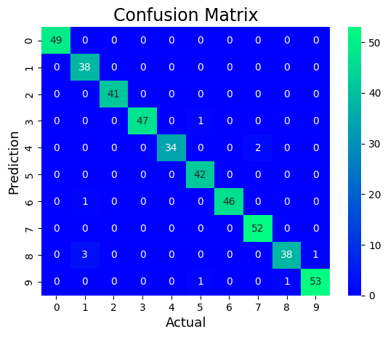
Accuracy : 0.9777777777777777
Experiment 4:
Aim: To analyse the performance of a over fitting by using choosen database with python code
Program:
import numpy as np
import matplotlib.pyplot as plt
from sklearn.pipeline import Pipeline
from sklearn.preprocessing import PolynomialFeatures
from sklearn.linear_model import LinearRegression
from sklearn.model_selection import cross_val_score

def true_fun(X):
return np.cos(1.5 * np.pi * X)

np.random.seed(0)

n_samples = 30
degrees = [1, 4, 15]

X = np.sort(np.random.rand(n_samples))
y = true_fun(X) + np.random.randn(n_samples) * 0.1

plt.figure(figsize=(14, 5))
for i in range(len(degrees)):
ax = plt.subplot(1, len(degrees), i + 1)
plt.setp(ax, xticks=(), yticks=())

polynomial_features = PolynomialFeatures(degree=degrees[i], include_bias=False)
linear_regression = LinearRegression()
pipeline = Pipeline(
[
("polynomial_features", polynomial_features),
("linear_regression", linear_regression),
]
)
pipeline.fit(X[:, np.newaxis], y)
scores = cross_val_score(
pipeline, X[:, np.newaxis], y, scoring="neg_mean_squared_error", cv=10
)

X_test = np.linspace(0, 1, 100)
plt.plot(X_test, pipeline.predict(X_test[:, np.newaxis]), label="Model")
plt.plot(X_test, true_fun(X_test), label="True function")
plt.scatter(X, y, edgecolor="y", s=20,marker="^", label="Samples")
plt.xlabel("x")
plt.ylabel("y")
plt.xlim((0, 1))
plt.ylim((-2, 2))
plt.legend(loc="best")
plt.title(
"Degree {}\nMSE = {:.2e}(+/- {:.2e})".format(
degrees[i], -scores.mean(), scores.std()
)
)
plt.show()
Output:
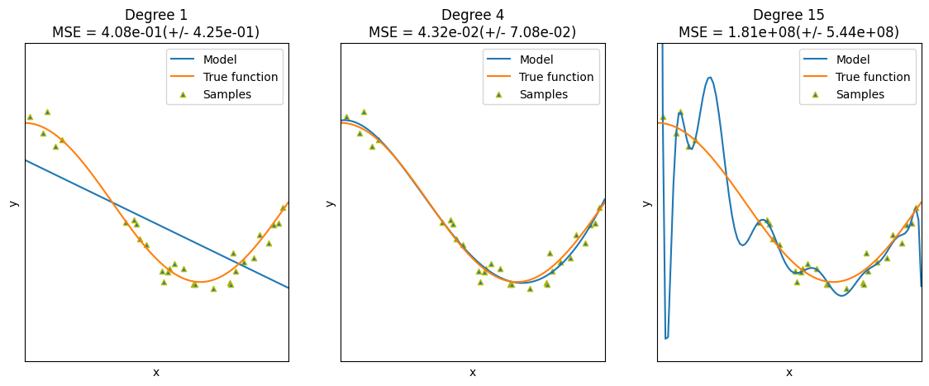
Experiment 5:
Aim: To demonstrate the performance of a linear regression by using choosen database with python code
Program:
import pandas as pd
import matplotlib.pyplot as plt
from sklearn.datasets import load_iris
from sklearn.model_selection import train_test_split
from sklearn.linear_model import LinearRegression
from sklearn.metrics import mean_squared_error
iris = load_iris()
data = pd.DataFrame(data=iris.data, columns=iris.feature_names)
data['species'] = iris.target
print(data.head())
X = data[['sepal length (cm)']]
y = data['sepal width (cm)']
X_train, X_test, y_train, y_test = train_test_split(X, y, test_size=0.3, random_state=42)
model = LinearRegression()
model.fit(X_train, y_train)
y_pred = model.predict(X_test)
mse = mean_squared_error(y_test, y_pred)
print(f'Mean Squared Error on test set: {mse:.2f}')
plt.figure(figsize=(10, 6))
plt.scatter(X_test, y_test, color='r',marker='*', label='Actual')
plt.plot(X_test, y_pred, color='y', linewidth=3, label='Predicted')
plt.xlabel('Sepal Length (cm)')
plt.ylabel('Sepal Width (cm)')
plt.title('Linear Regression: Sepal Width vs Sepal Length')
plt.legend()
plt.show()
new_sample = pd.DataFrame([[5]], columns=['sepal length (cm)'])
predicted_width = model.predict(new_sample)
print(f'The predicted sepal width for sepal length {new_sample.values.tolist()} is {predicted_width[0]:.2f} cm')

Output:
Mean Squared Error on test set: 0.23
The predicted sepal width for sepal length [[5]] is 3.02 cm

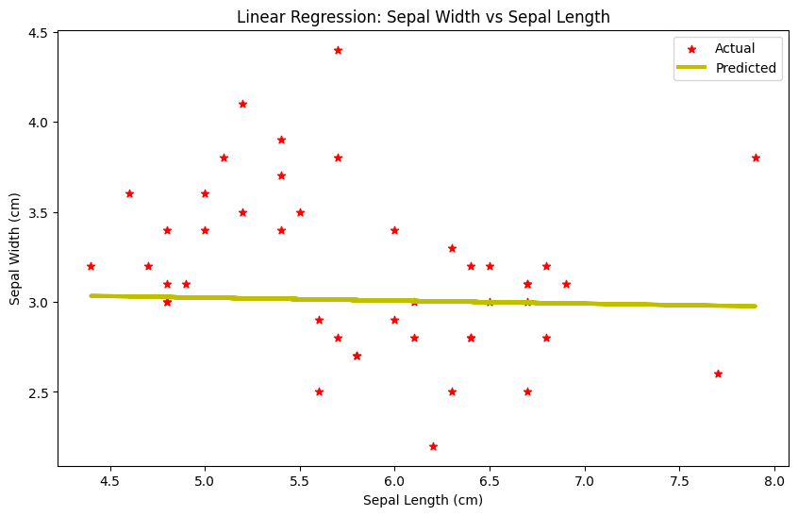
Experiment 6:
Aim: To demonstrate the performance of knn using wine dataset
Program:
import pandas as pd
import pandas as pd
import matplotlib.pyplot as plt
import seaborn as sns
from sklearn.datasets import load_wine
from sklearn.model_selection import train_test_split
from sklearn.neighbors import KNeighborsClassifier
from sklearn.metrics import accuracy_score,confusion_matrix
wine=load_wine()
data=pd.DataFrame(data=wine.data,columns=wine.feature_names)
data['Target']=wine.target
x=data.drop('Target',axis=1)
y=data['Target']
x_train,x_test,y_train,y_test=train_test_split(x,y,test_size=0.3,random_state=1)
model=KNeighborsClassifier(n_neighbors=5)
model.fit(x_train,y_train)
y_pred=model.predict(x_test)
accuracy=accuracy_score(y_test,y_pred)
print("accuracy:",accuracy)
conf_matrix = confusion_matrix(y_test,y_pred)
plt.figure(figsize=(8, 6))
sns.heatmap(conf_matrix, annot=True, fmt='d', cmap='summer', xticklabels=wine.target_names, yticklabels=wine.target_names)
plt.xlabel('Predicted Label')
plt.ylabel('True Label')
plt.title('Confusion Matrix')
plt.show()
Output:
accuracy: 0.7037037037037037
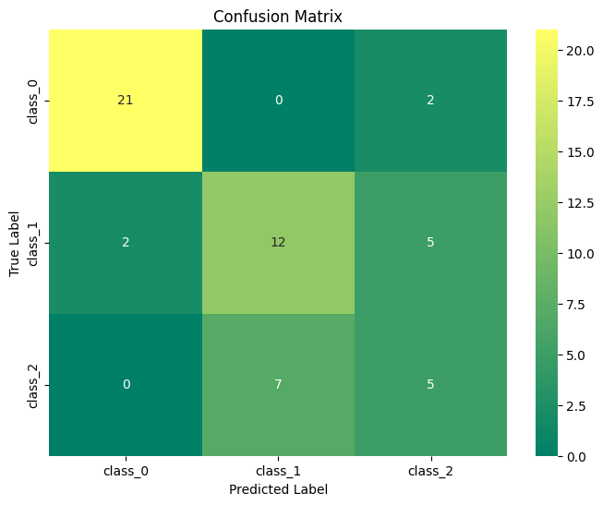

Experiment 7:
Aim: To demonstrate the performance of a logistic regression by using choosen database with python code.
Program:
import numpy as np
import matplotlib.pyplot as plt
def sigmoid(z):
return 1 / (1 + np.exp( - z))
plt.plot(np.arange(-5, 5, 0.1), sigmoid(np.arange(-5, 5, 0.1)),color='pink')
plt.title('Visualization of the Sigmoid Function')
plt.show()

Output:
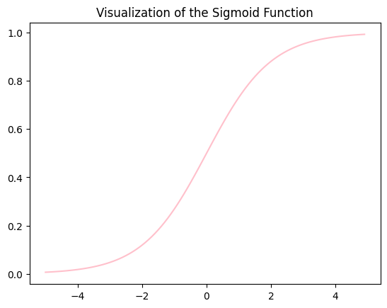
Experiment 8:
Aim: To demonstrate the performance of KNN algorithm by using iris dataset
Program:
import pandas as pd
import matplotlib.pyplot as plt
import seaborn as sns
from sklearn.datasets import load_iris
from sklearn.model_selection import train_test_split
from sklearn.neighbors import KNeighborsClassifier
from sklearn.metrics import accuracy_score,confusion_matrix
iris=load_iris()
data=pd.DataFrame(data=iris.data,columns=iris.feature_names)
data['Species']=iris.target
x=data.drop('Species',axis=1)
y=data['Species']
x_train,x_test,y_train,y_test=train_test_split(x,y,test_size=0.3,random_state=1)
model=KNeighborsClassifier(n_neighbors=5)
model.fit(x_train,y_train)
y_pred=model.predict(x_test)
accuracy=accuracy_score(y_test,y_pred)
print("accuracy:",accuracy)
conf_matrix = confusion_matrix(y_test,y_pred)
plt.figure(figsize=(8, 6))
sns.heatmap(conf_matrix, annot=True, fmt='d', cmap='pink', xticklabels=iris.target_names, yticklabels=iris.target_names)
plt.xlabel('Predicted Label')
plt.ylabel('True Label')
plt.title('Confusion Matrix')
plt.show()
Output:
accuracy: 0.9777777777777777
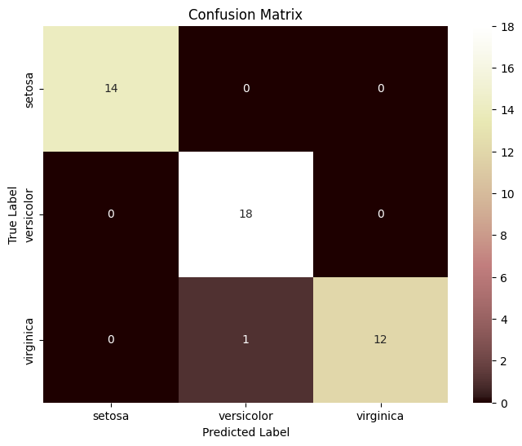

Experiment 9:
Aim: : To demonstrate the performance of Naïve Bayes algorithm by using iris dataset
Program:
#naive bayes iris
import pandas as pd
import matplotlib.pyplot as plt
import seaborn as sns
from sklearn.datasets import load_iris
from sklearn.model_selection import train_test_split
from sklearn.naive_bayes import GaussianNB
from sklearn.metrics import accuracy_score,confusion_matrix
iris = load_iris()
data = pd.DataFrame(data=iris.data, columns=iris.feature_names)
data['species'] = iris.target
X = data.drop('species', axis=1)
y = data['species']
X_train, X_test, y_train, y_test = train_test_split(X, y, test_size=0.3, random_state=42)
model = GaussianNB()
model.fit(X_train, y_train)
y_pred = model.predict(X_test)
accuracy = accuracy_score(y_test, y_pred)
print("accuracy:",accuracy)
conf_matrix = confusion_matrix(y_test,y_pred)
plt.figure(figsize=(8, 6))
sns.heatmap(conf_matrix, annot=True, fmt='d', cmap='vanimo', xticklabels=iris.target_names, yticklabels=iris.target_names)
plt.xlabel('Predicted Label')
plt.ylabel('True Label')
plt.title('Confusion Matrix')
plt.show()
Output:
accuracy: 0.9777777777777777
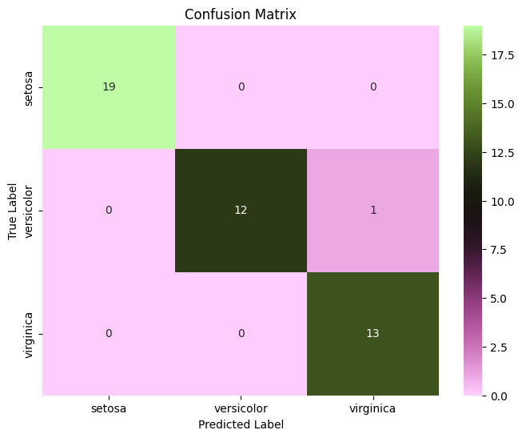

Experiment 10:
Aim: To demonstrate the performance of Logistic Regression using iris dataset
Program:
import pandas as pd
import matplotlib.pyplot as plt
import seaborn as sns
from sklearn.datasets import load_iris
from sklearn.model_selection import train_test_split
from sklearn.linear_model import LogisticRegression
from sklearn.metrics import accuracy_score,confusion_matrix
iris = load_iris()
data = pd.DataFrame(data=iris.data, columns=iris.feature_names)
data['species'] = iris.target
X = data.drop('species', axis=1)
y = data['species']
X_train, X_test, y_train, y_test = train_test_split(X, y, test_size=0.2, random_state=1)
model =LogisticRegression(max_iter=200)
model.fit(X_train, y_train)
y_pred = model.predict(X_test)
accuracy = accuracy_score(y_test, y_pred)
print("accuracy:",accuracy)
conf_matrix = confusion_matrix(y_test,y_pred)
plt.figure(figsize=(8, 6))
sns.heatmap(conf_matrix, annot=True, fmt='d', cmap='berlin', xticklabels=iris.target_names, yticklabels=iris.target_names)
plt.xlabel('Predicted Label')
plt.ylabel('True Label')
plt.title('Confusion Matrix')
plt.show()

Output:
accuracy: 0.9666666666666667
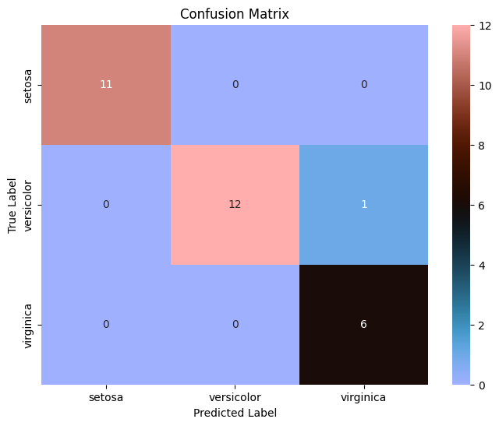

Experiment 11:
Aim: To demonstrate the performance of Decision tree Classifier algorithm using iris dataset.
Program:
import pandas as pd
import matplotlib.pyplot as plt
import seaborn as sns
from sklearn.datasets import load_iris
from sklearn.model_selection import train_test_split
from sklearn.tree import DecisionTreeClassifier
from sklearn.metrics import accuracy_score,confusion_matrix
iris = load_iris()
data = pd.DataFrame(data=iris.data, columns=iris.feature_names)
data['species'] = iris.target
X = data.drop('species', axis=1)
y = data['species']
X_train, X_test, y_train, y_test = train_test_split(X, y, test_size=0.2, random_state=1)
model =DecisionTreeClassifier()
model.fit(X_train, y_train)
y_pred = model.predict(X_test)
accuracy = accuracy_score(y_test, y_pred)
print("accuracy:",accuracy)
conf_matrix = confusion_matrix(y_test,y_pred)
plt.figure(figsize=(8, 6))
sns.heatmap(conf_matrix, annot=True, fmt='d', cmap='PRGn', xticklabels=iris.target_names, yticklabels=iris.target_names)
plt.xlabel('Predicted Label')
plt.ylabel('True Label')
plt.title('Confusion Matrix')
plt.show()

Output:
accuracy: 0.9666666666666667
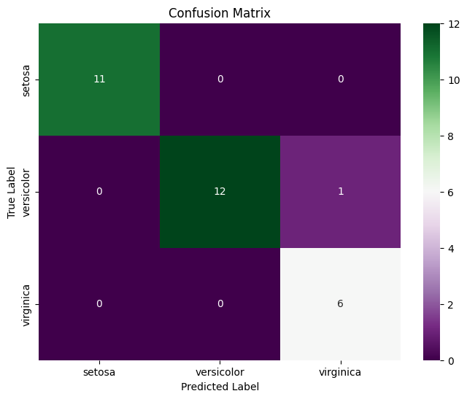
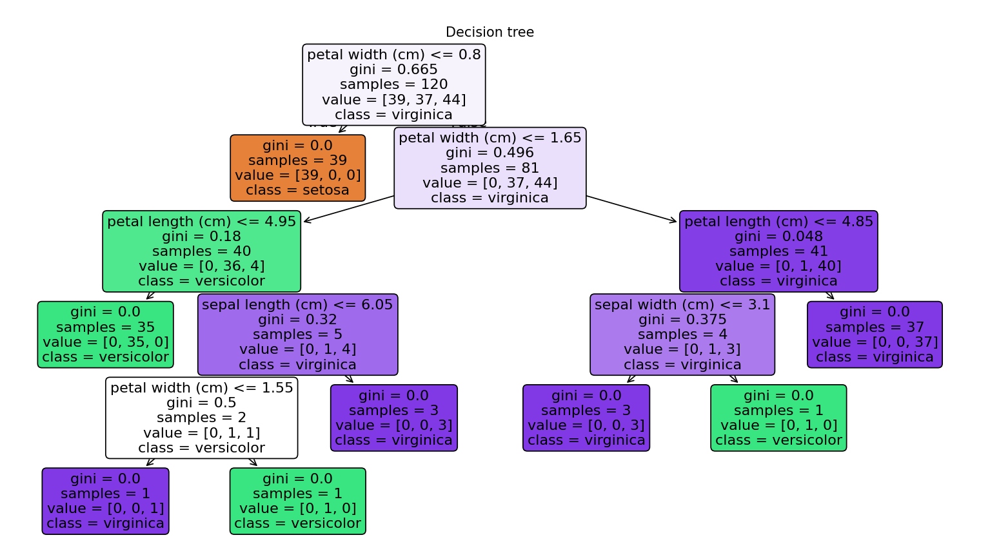

Experiment 12:
Aim: To demonstrate the performance of Random Forest classifier algorithm by using iris dataset
Program:
import pandas as pd
import matplotlib.pyplot as plt
import seaborn as sns
from sklearn.datasets import load_iris
from sklearn.model_selection import train_test_split
from sklearn.ensemble import RandomForestClassifier
from sklearn.metrics import accuracy_score,confusion_matrix
iris=load_iris()
data=pd.DataFrame(data=iris.data,columns=iris.feature_names)
data['Species']=iris.target
x=data.drop('Species',axis=1)
y=data['Species']
x_train,x_test,y_train,y_test=train_test_split(x,y,test_size=0.3,random_state=1)
model=RandomForestClassifier(n_estimators=100,random_state=1)
model.fit(x_train,y_train)
y_pred=model.predict(x_test)
accuracy=accuracy_score(y_test,y_pred)
print("accuracy:",accuracy)
conf_matrix = confusion_matrix(y_test,y_pred)
plt.figure(figsize=(8, 6))
sns.heatmap(conf_matrix, annot=True, fmt='d', cmap='managua', xticklabels=iris.target_names, yticklabels=iris.target_names)
plt.xlabel('Predicted Label')
plt.ylabel('True Label')
plt.title('Confusion Matrix')
plt.show()

Output:
accuracy: 0.9555555555555556
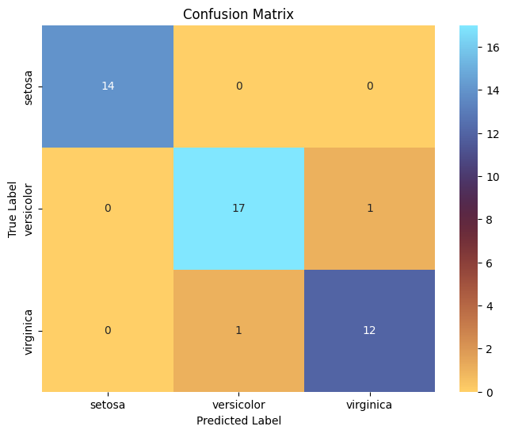
Experiment 13:
Aim: To demonstrate the performance of SVM algorithm by using iris dataset
Program:
import pandas as pd
import matplotlib.pyplot as plt
import seaborn as sns
from sklearn.datasets import load_iris
from sklearn.model_selection import train_test_split
from sklearn.svm import SVC
from sklearn.metrics import accuracy_score,confusion_matrix
iris=load_iris()
data=pd.DataFrame(data=iris.data,columns=iris.feature_names)
data['Species']=iris.target
x=data.drop('Species',axis=1)
y=data['Species']
x_train,x_test,y_train,y_test=train_test_split(x,y,test_size=0.2,random_state=1)
model=SVC(kernel='poly',random_state=1)
model.fit(x_train,y_train)
y_pred=model.predict(x_test)
accuracy=accuracy_score(y_test,y_pred)
print("accuracy:",accuracy)
conf_matrix = confusion_matrix(y_test,y_pred)
plt.figure(figsize=(8, 6))
sns.heatmap(conf_matrix, annot=True, fmt='d', cmap='turbo', xticklabels=iris.target_names, yticklabels=iris.target_names)
plt.xlabel('Predicted Label')
plt.ylabel('True Label')
plt.title('Confusion Matrix')
plt.show()

Output:
accuracy: 0.9666666666666667
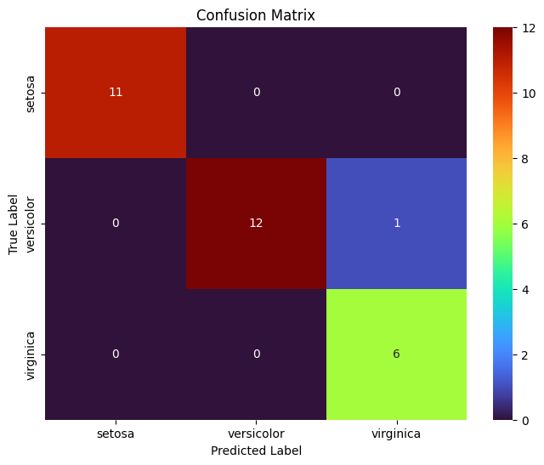
Experiment 14:
Aim: To demonstrate the gradient descent
Program:
import numpy as np
import matplotlib.pyplot as plt
from sklearn.preprocessing import StandardScaler
def mean_squared_error(y_true, y_predicted):
cost = np.sum((y_true - y_predicted)**2) / len(y_true)
return cost
def gradient_descent(x, y, iterations=1000, learning_rate=0.01, stopping_threshold=1e-6):
current_weight = 0.0
current_bias = 0.0
n = float(len(x))
costs = []
previous_cost = None
for i in range(iterations):
y_predicted = current_weight * x + current_bias
current_cost = mean_squared_error(y, y_predicted)
if previous_cost and abs(previous_cost - current_cost) <= stopping_threshold:
break
previous_cost = current_cost
costs.append(current_cost)
weight_derivative = -(2/n) * sum(x * (y - y_predicted))
bias_derivative = -(2/n) * sum(y - y_predicted)
current_weight = current_weight - learning_rate * weight_derivative
current_bias = current_bias - learning_rate * bias_derivative
if i % 100 == 0:
print(f"Iteration {i+1}: Cost {current_cost}, Weight {current_weight}, Bias {current_bias}")
plt.figure(figsize=(8,6))
plt.plot(range(len(costs)), costs, 'r.')
plt.title("Cost vs Iterations")
plt.xlabel("Iterations")
plt.ylabel("Cost")
plt.show()
return current_weight, current_bias
def main():
X = np.array([32.5, 53.4, 61.5, 47.4, 59.8, 55.1, 52.2, 39.2, 48.1, 52.5, 45.4, 54.3, 44.1, 58.1, 56.7, 48.9, 44.6, 60.2, 45.6, 38.8])
Y = np.array([31.7, 68.7, 62.5, 71.5, 87.2, 78.2, 79.6, 59.1, 75.3, 71.3, 55.1, 82.4, 62.0, 75.3, 81.4, 60.7, 82.8, 97.3, 48.8, 56.8])
scaler = StandardScaler()
X_normalized = scaler.fit_transform(X.reshape(-1, 1)).flatten()
estimated_weight, estimated_bias = gradient_descent(X_normalized, Y, iterations=2000, learning_rate=0.01)
print(f"Estimated Weight: {estimated_weight}, Estimated Bias: {estimated_bias}")
Y_pred = estimated_weight * X_normalized + estimated_bias
plt.figure(figsize=(8,6))
plt.scatter(X, Y, color='black', label='Data Points',marker='*')
plt.plot(X, Y_pred, color='red', linestyle='--', label='Fitted Line')
plt.xlabel("X")
plt.ylabel("Y")
plt.title("Linear Regression using Gradient Descent")
plt.legend()
plt.show()

if __name__ == "__main__":
main()

Output:
Iteration 1: Cost 5031.3015, Weight 0.21744528996901658, Bias 1.3877
Iteration 101: Cost 185.56941123866557, Weight 9.459227106883091, Bias 60.3672282719577
Iteration 201: Cost 100.34293399589959, Weight 10.684868107118445, Bias 68.18906711826675
Iteration 301: Cost 98.84397526476002, Weight 10.847412072256065, Bias 69.22639591234459
Iteration 401: Cost 98.81761165863254, Weight 10.868968580725983, Bias 69.36396599633204
Estimated Weight: 10.87151030998278, Estimated Bias: 69.38018689350649
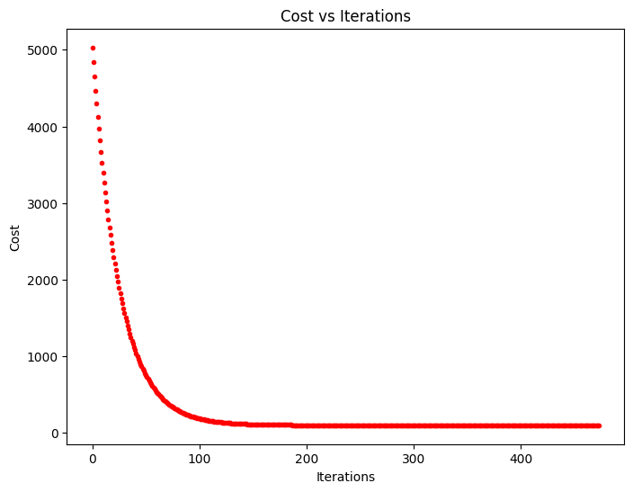
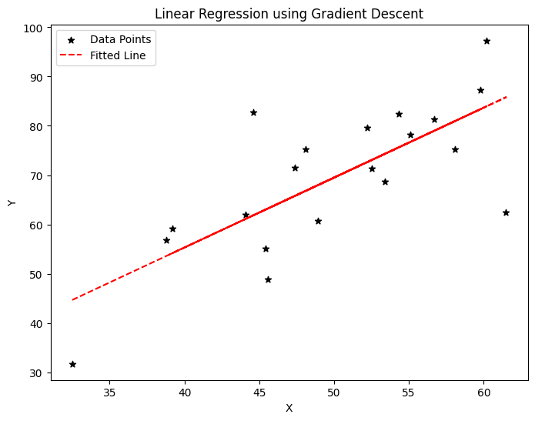

Experiment 15:
Aim: To demonstrate the segmentation of image using python
Program:
import cv2
import numpy as np
from matplotlib import pyplot as plt
img = cv2.imread('C:\desktop\core project\dataset\cataract\_16_1907643.jpg')
rgb_img = cv2.cvtColor(img, cv2.COLOR_BGR2RGB)
pixels = rgb_img.reshape((-1, 3))
pixels = np.float32(pixels)
criteria = (cv2.TERM_CRITERIA_EPS + cv2.TERM_CRITERIA_MAX_ITER, 100, 0.2)
K = 3
_, labels, centers = cv2.kmeans(pixels, K, None, criteria, 10, cv2.KMEANS_RANDOM_CENTERS)
centers = np.uint8(centers)
segmented_img = centers[labels.flatten()]
segmented_img = segmented_img.reshape(rgb_img.shape)
plt.figure(figsize=(10, 5))
plt.subplot(121)
plt.imshow(rgb_img)
plt.title('Original Image')
plt.axis('off')

plt.subplot(122)
plt.imshow(segmented_img)
plt.title('Segmented Image (K-means)')
plt.axis('off')

plt.tight_layout()
plt.show()
Output:
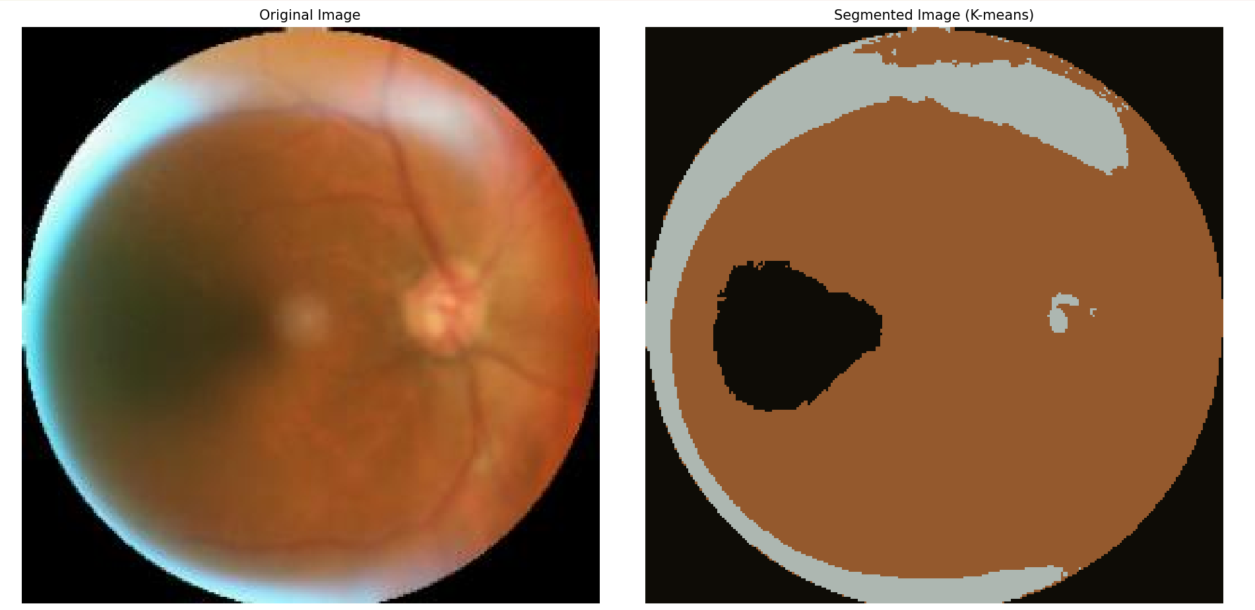

Experiment 16:
Aim: To demonstrate the segmentation of image using python
Program:
import numpy as np
import cv2
from matplotlib import pyplot as plt
img = cv2.imread(r'C:\desktop\core project\dataset\cataract\_16_1907643.jpg')
b, g, r = cv2.split(img)
rgb_img = cv2.merge([r, g, b])
gray = cv2.cvtColor(img, cv2.COLOR_BGR2GRAY)
ret, thresh = cv2.threshold(gray, 0, 255, cv2.THRESH_BINARY_INV + cv2.THRESH_OTSU)
kernel = np.ones((2, 2), np.uint8)
closing = cv2.morphologyEx(thresh, cv2.MORPH_CLOSE, kernel, iterations=2)
sure_bg = cv2.dilate(closing, kernel, iterations=3)
plt.figure(figsize=(12, 8))

plt.subplot(231)
plt.imshow(rgb_img)
plt.title("Original Image")
plt.xticks([]), plt.yticks([])

plt.subplot(232)
plt.imshow(gray, 'gray')
plt.title("Grayscale Image")
plt.xticks([]), plt.yticks([])

plt.subplot(233)
plt.imshow(thresh, 'gray')
plt.title("Otsu's Threshold")
plt.xticks([]), plt.yticks([])

plt.subplot(234)
plt.imshow(closing, 'gray')
plt.title("MorphologyEx: Closing (2x2)")
plt.xticks([]), plt.yticks([])

plt.subplot(235)
plt.imshow(sure_bg, 'gray')
plt.title("Dilation")
plt.xticks([]), plt.yticks([])

plt.tight_layout()
plt.show()
plt.imsave(r'dilation.png', sure_bg)

Output:
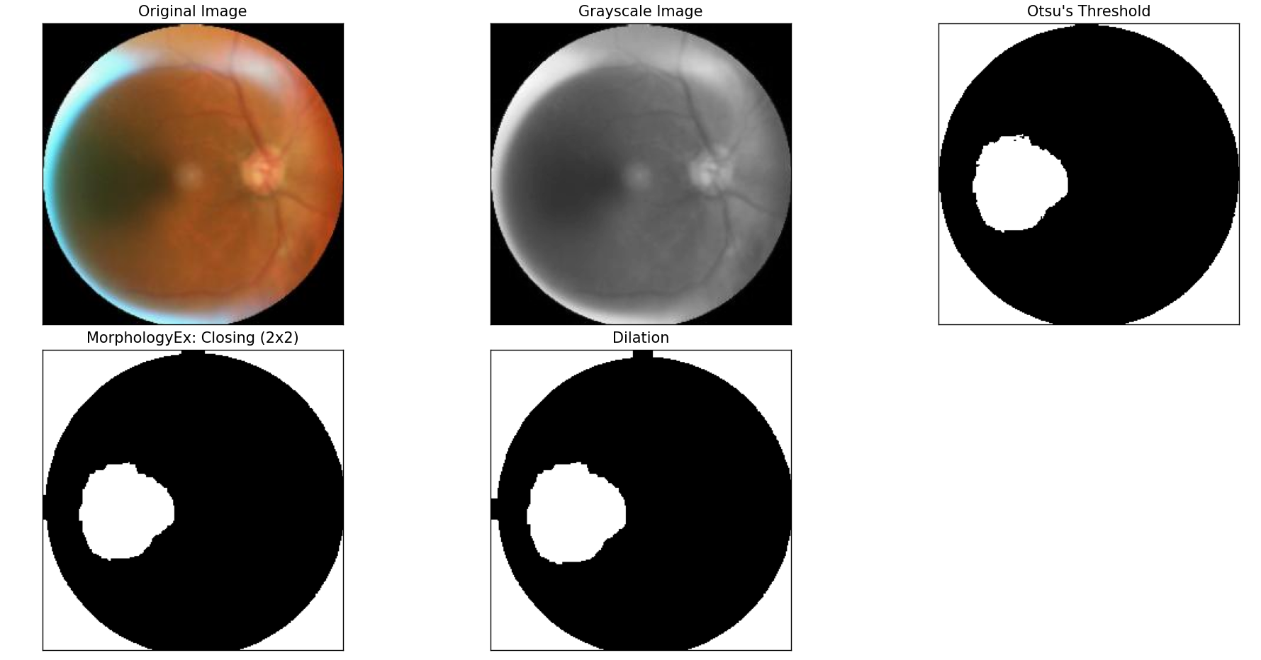

Experiment 17:
Aim: To demonstrate linear separability using python code
Program:
import numpy as np
import matplotlib.pyplot as plt
from sklearn.datasets import make_classification
from sklearn.linear_model import LogisticRegression
from sklearn.metrics import accuracy_score
X, y = make_classification(n_samples=100, n_features=2, n_informative=2, n_redundant=0, n_clusters_per_class=1, random_state=42)
model = LogisticRegression()
model.fit(X, y)
y_pred = model.predict(X)
accuracy = accuracy_score(y, y_pred)
print(f"Accuracy: {accuracy:.2f}")
plt.figure(figsize=(10, 6))
plt.scatter(X[:, 0], X[:, 1], c=y, cmap='berlin', edgecolor='m', s=50)
coef = model.coef_[0]
intercept = model.intercept_
x_vals = np.linspace(X[:, 0].min(), X[:, 0].max(), 100)
y_vals = - (coef[0] * x_vals + intercept) / coef[1]
plt.plot(x_vals, y_vals, 'k--')

plt.xlabel('Feature 1')
plt.ylabel('Feature 2')
plt.title('Linear Separability Demonstration')
plt.show()
i
Output:
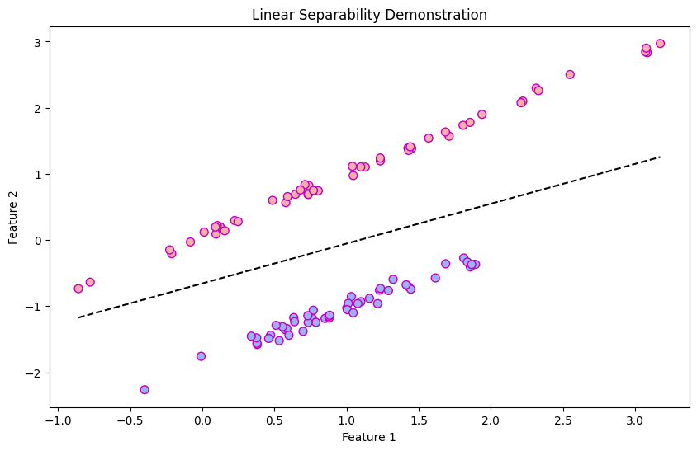
Experiment 18:
Aim: Neural network analysis for Two class, Learning rate: 0.03, Activation: Linear, Hidden Layers: 02, and Hidden neurons: 03.
Output:
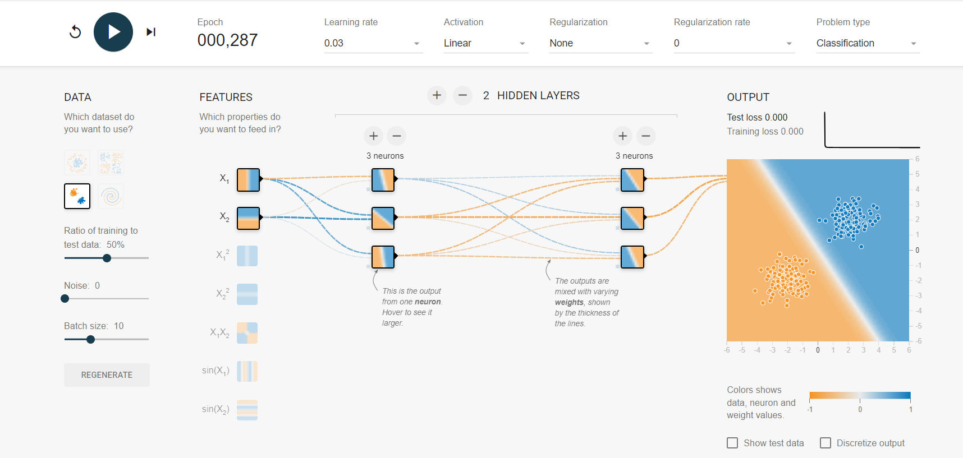
Experiment 19:
Aim: Neural network analysis for circular data class, Learning rate: 0.03, Activation: Linear, Hidden Layers: 02, and Hidden neurons: 03.
Output:
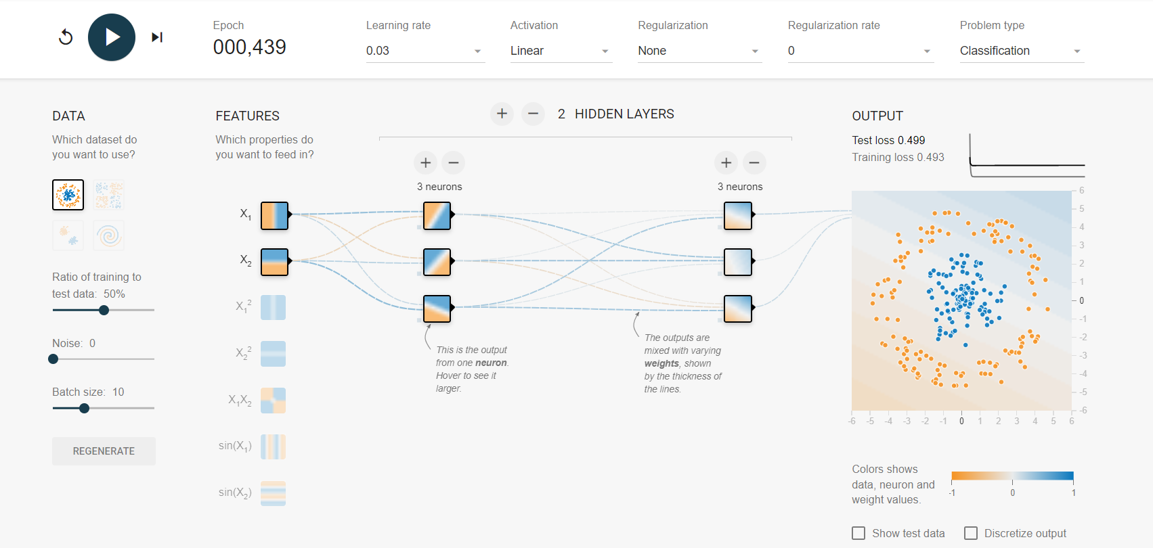
Experiment 20:
Aim: Neural network analysis for Multi class, Learning rate: 0.01, Activation: Linear, Hidden Layers: 02, and Hidden neurons: 02
Output:
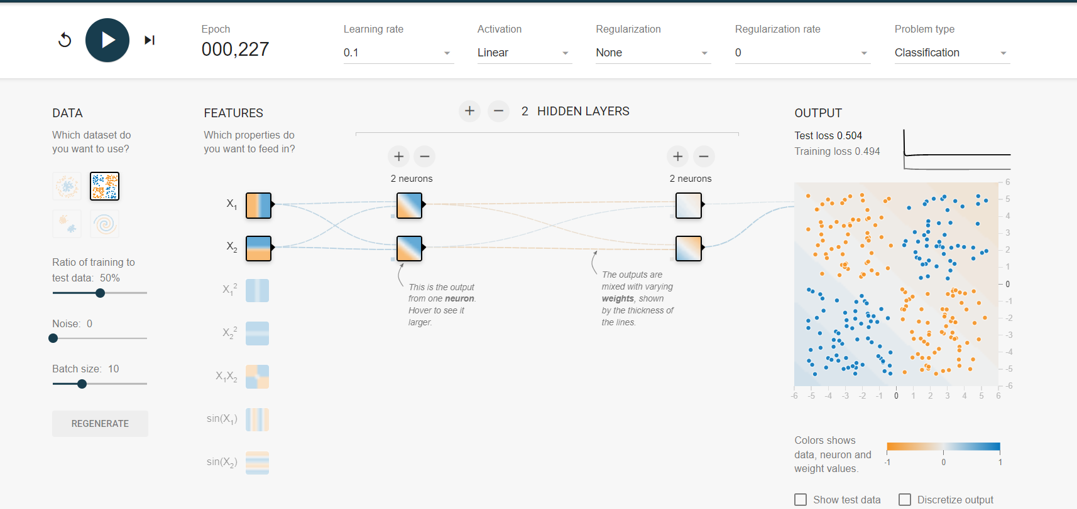
Experiment 21:
Aim: Neural network analysis for Circular data, Learning rate: 0.1, Activation: ReLU, Hidden Layers: 03, and Hidden neurons: 02.
Output:
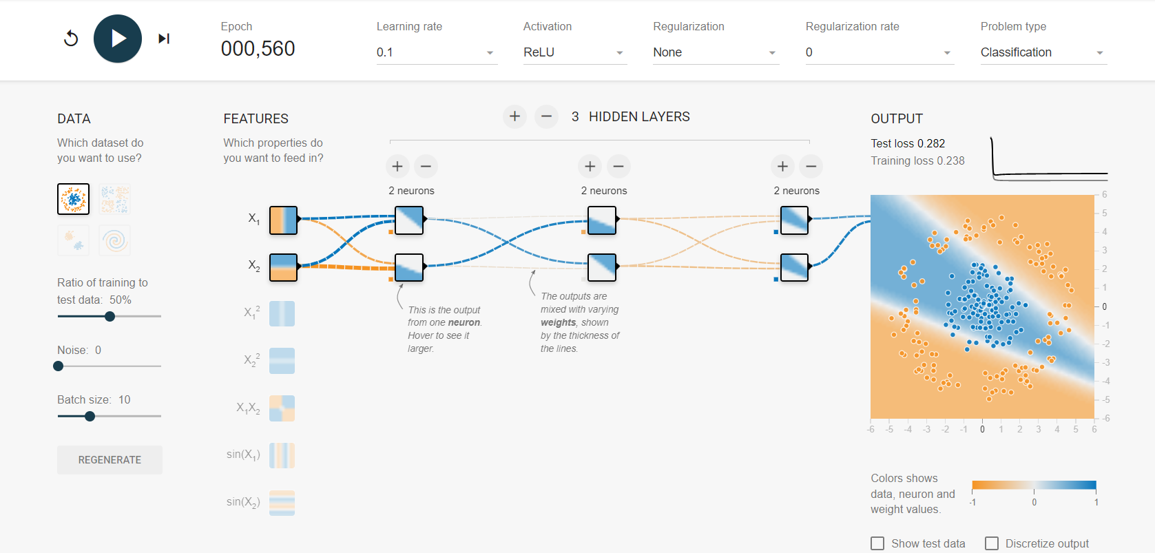
Experiment 22:
Aim: Neural network analysis for two class data, Learning rate: 0.1, Activation: ReLU, Hidden Layers: 03, and Hidden neurons: 02.
Output:
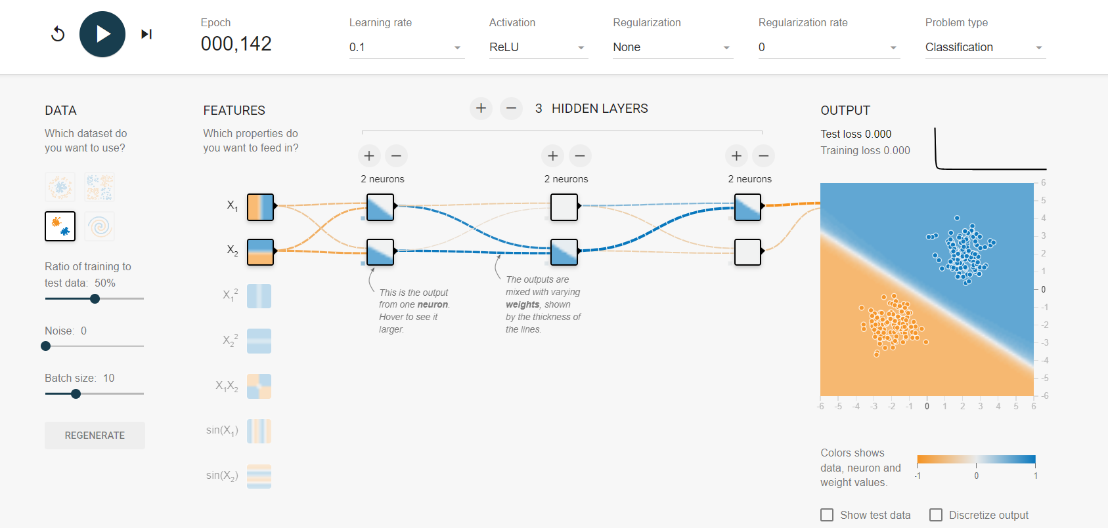
Experiment 23:
Aim: Neural network analysis for Spiral data, Learning rate: 0.1, Activation: Sigmoid, Hidden Layers: 03, and Hidden neurons: 03.
Output:
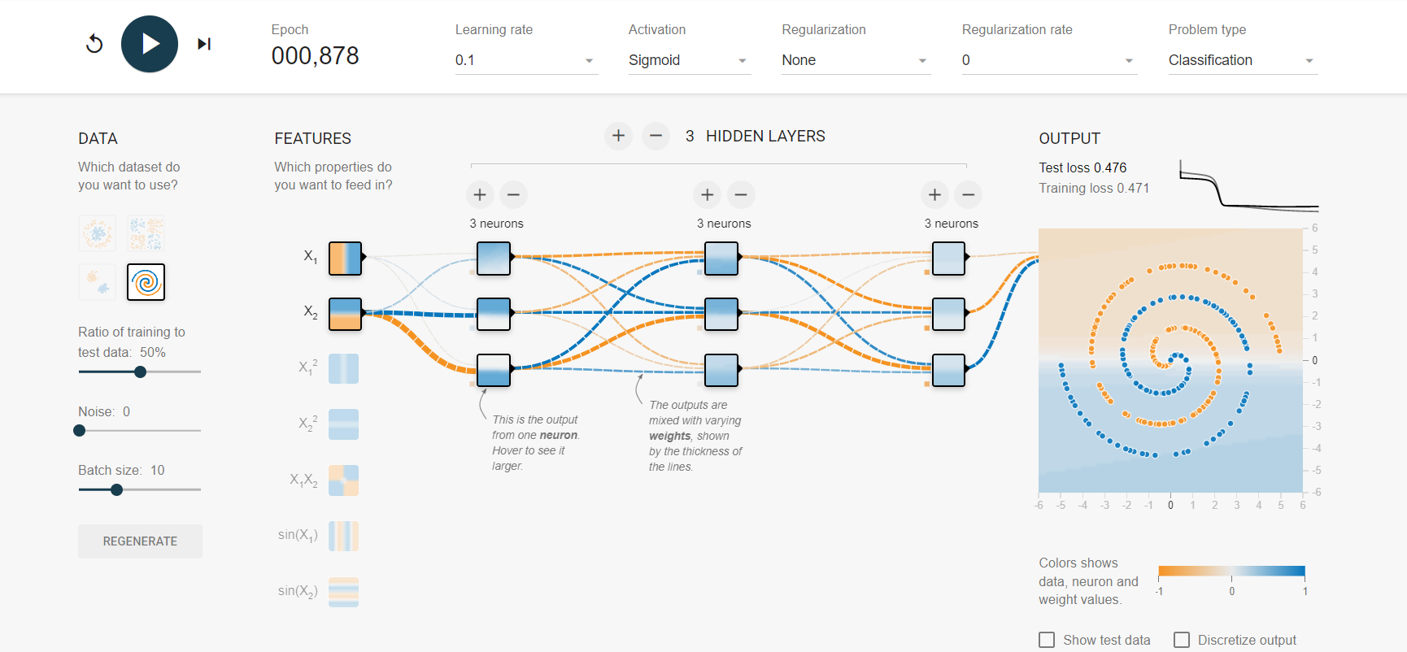

Experiment 24:
Aim: Neural network analysis for multi class data, Learning rate: 0.1, Activation: Sigmoid, Hidden Layers: 03, and Hidden neurons: 03.
Output:
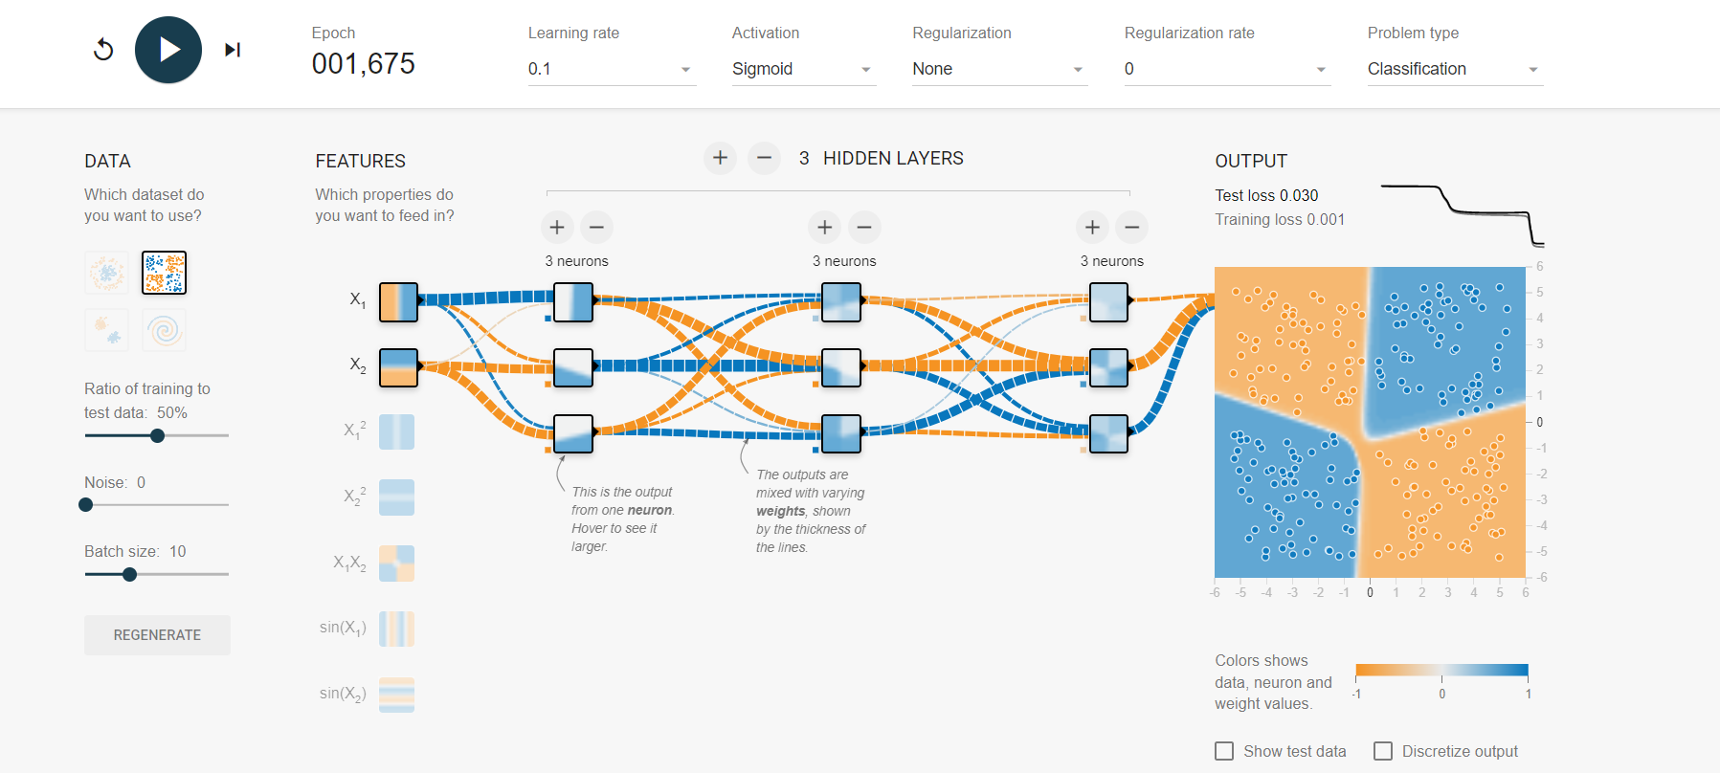
Experiment 25:
Aim: Neural network analysis for Circular data, Learning rate: 0.1, Activation: Tanh, Hidden Layers: 02, and Hidden neurons: 02.
Output:
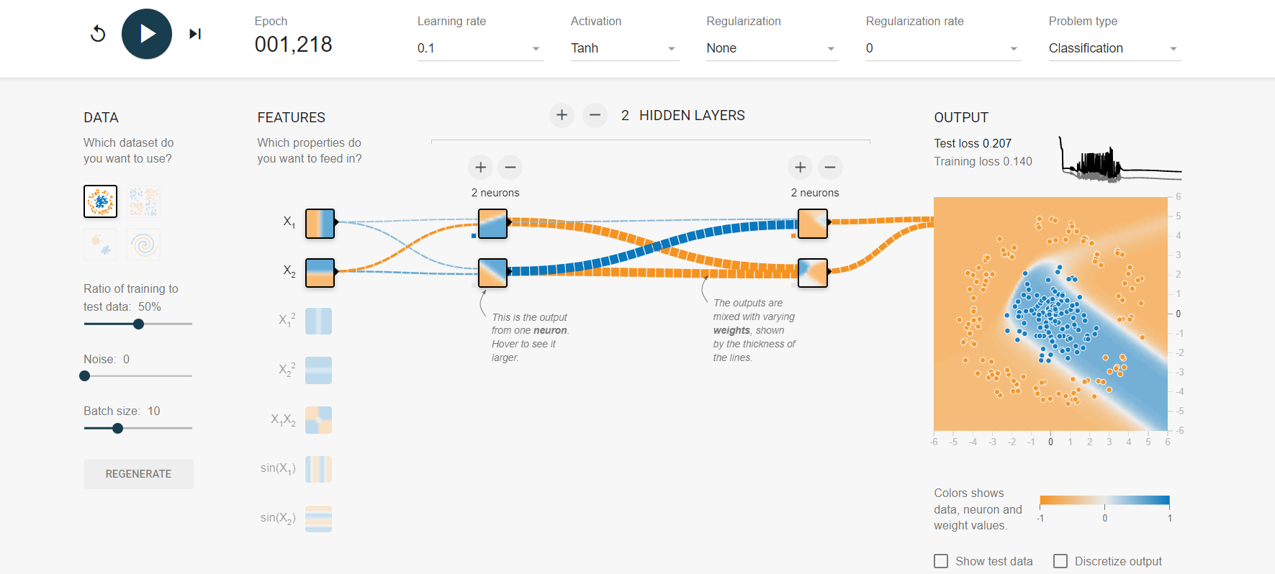
Experiment 26:
Aim: Neural network analysis for multi class data, Learning rate: 0.1, Activation: Tanh, Hidden Layers: 02, and Hidden neurons: 02.
Output:
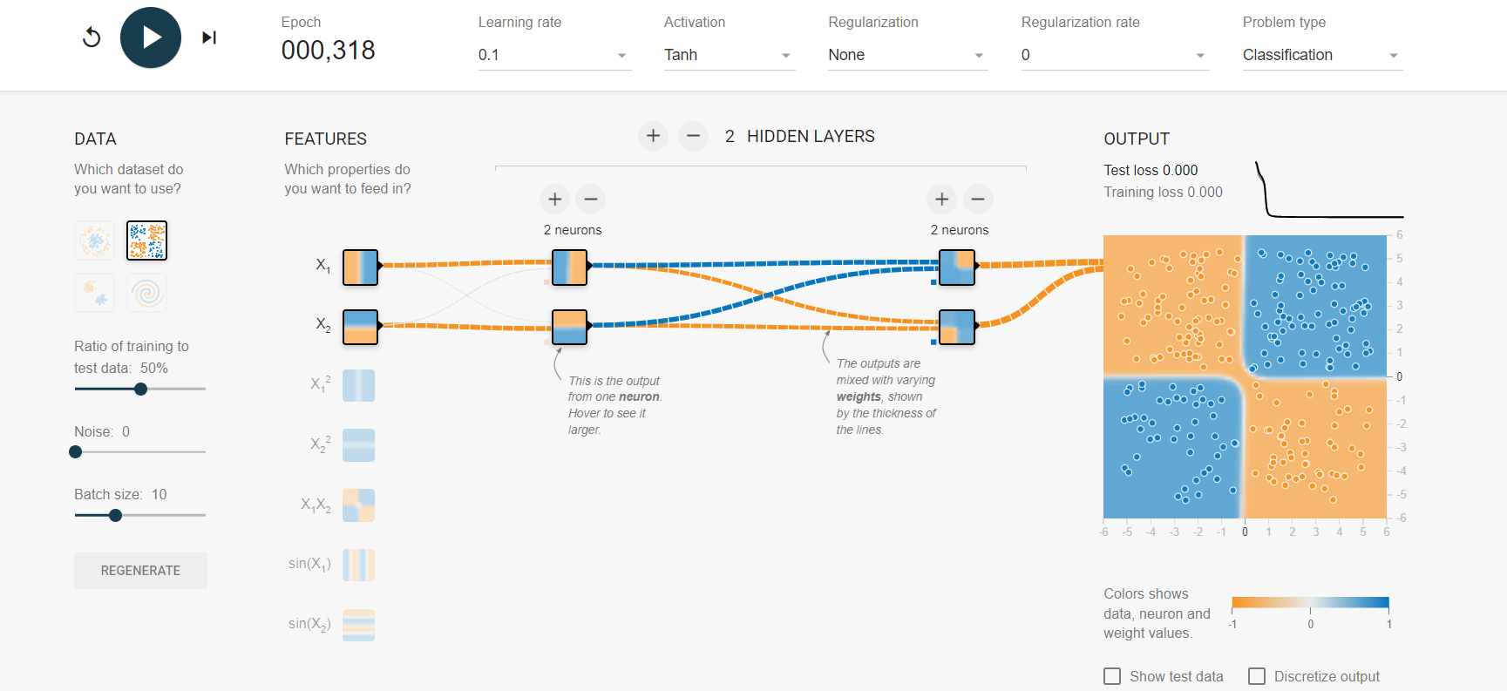
Experiment 27:
Aim: Neural network analysis for Two-class data, Learning rate: 0.001, Activation: ReLU, Hidden Layers: 03, and Hidden neurons: 02.
Output:
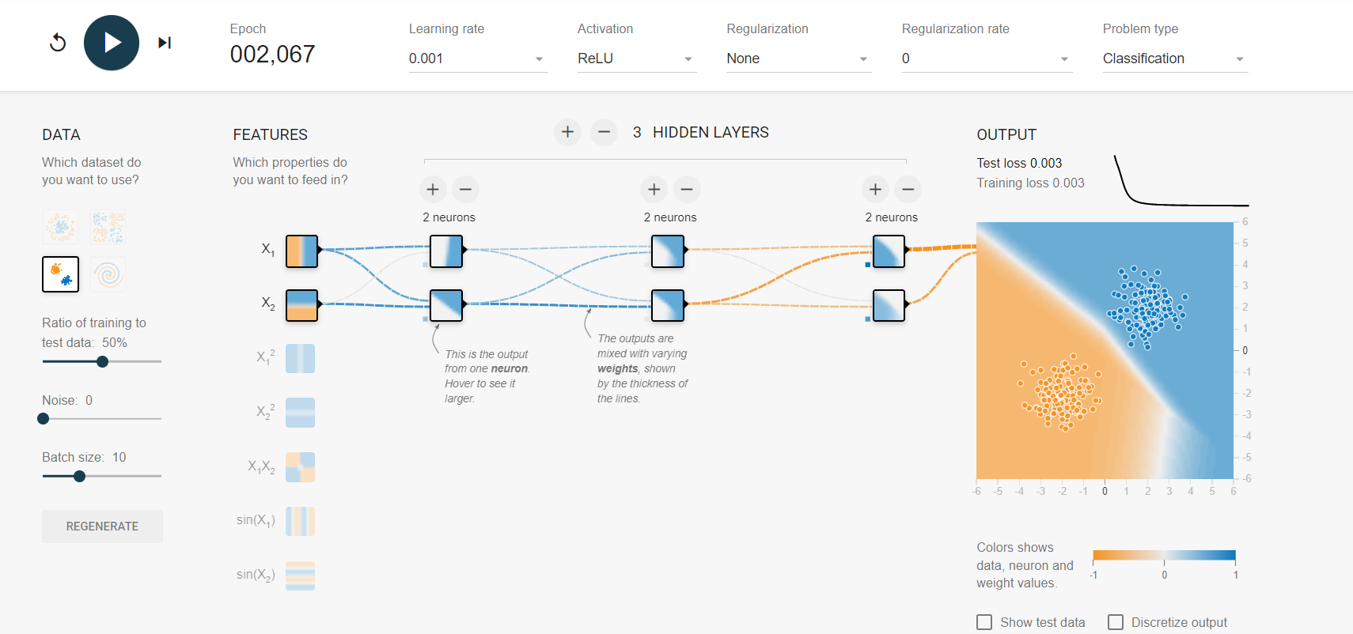
Experiment 28:
Aim: Neural network analysis for Multi class data, Learning rate: 0.001, Activation: ReLU, Hidden Layers: 03, and Hidden neurons: 02.
Output:
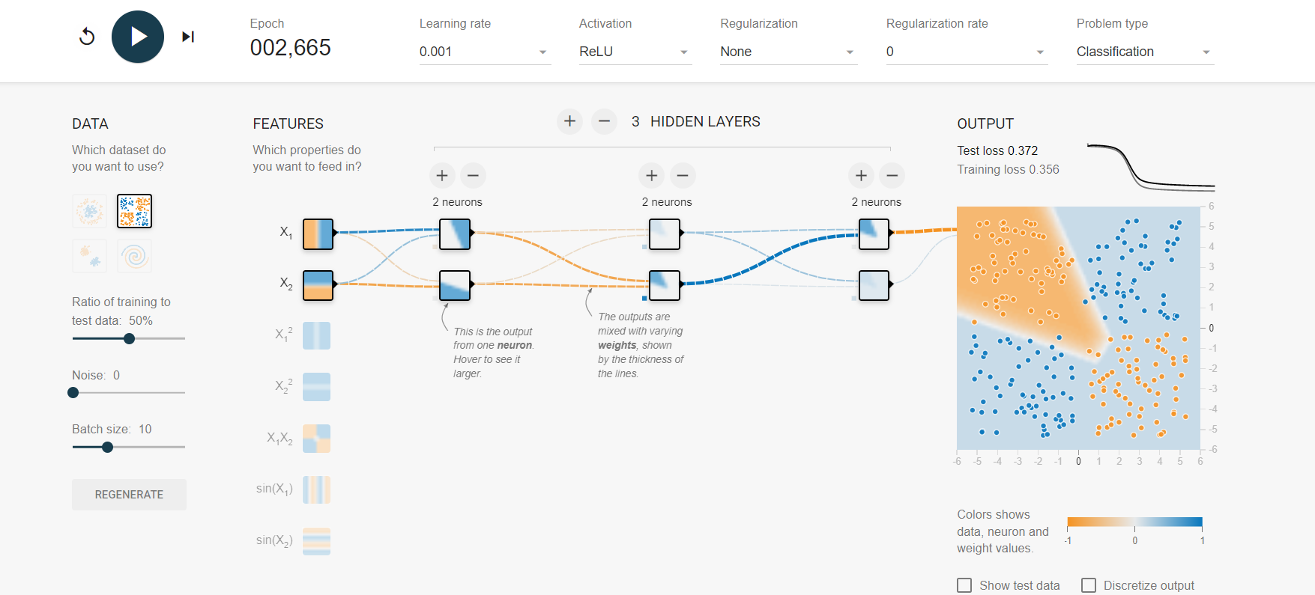
Experiment 29:
Aim: Neural network analysis for Multi-class data, Learning rate: 0.1, Activation: TanH, Hidden Layers: 03, and Hidden neurons: 03.
Output:
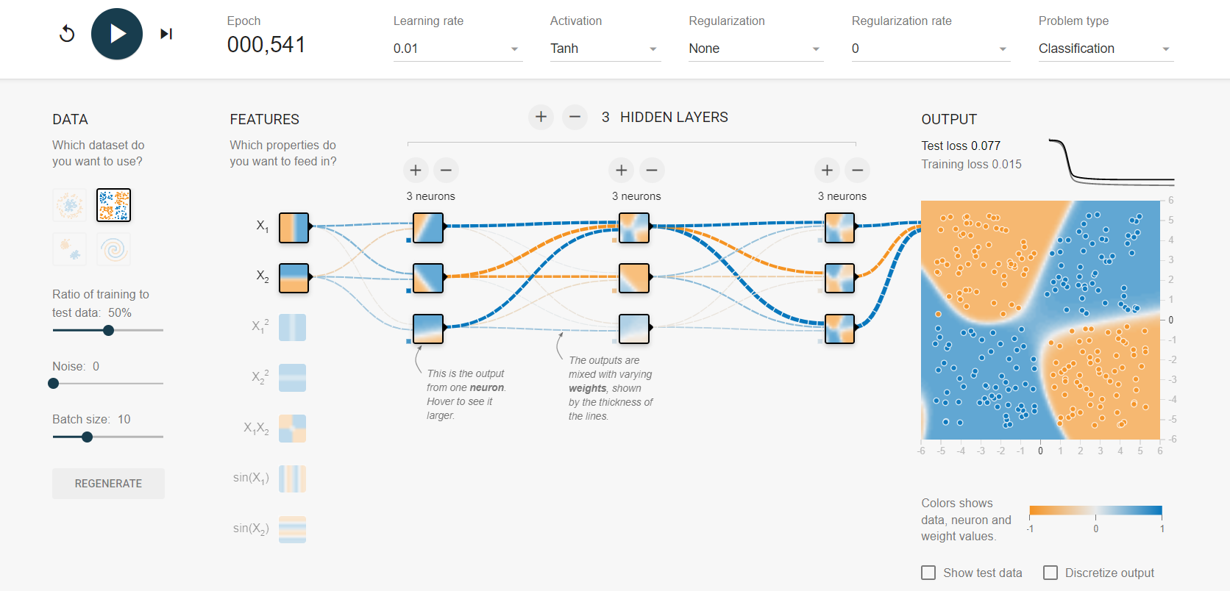
Experiment 30:
Aim: Neural network analysis for Two class data, Learning rate: 0.1, Activation: TanH, Hidden Layers: 03, and Hidden neurons: 03.
Output:
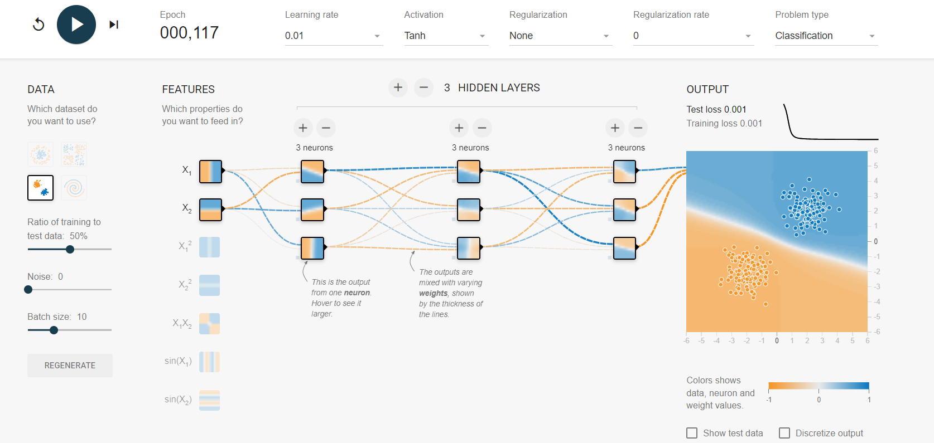
Experiment 31:
Aim: Neural network analysis for Multi-class data, Learning rate: 0.03, Activation: ReLu, Hidden Layers: 03, and Hidden neurons: 03.
Output:
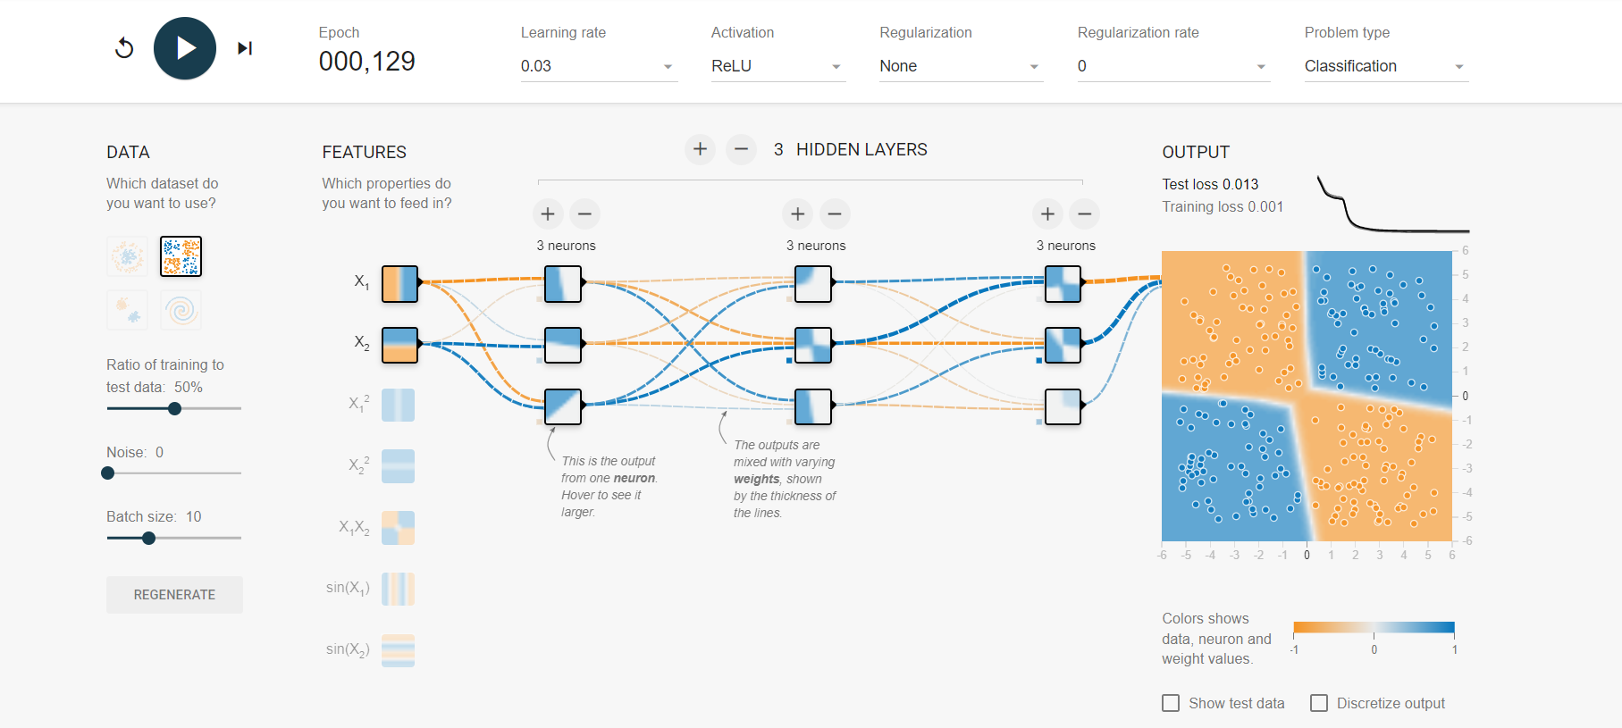
Experiment 32:
Aim: Neural network analysis for Two circular data, Learning rate: 0.1, Activation: TanH, Hidden Layers: 03, and Hidden neurons: 03.
Output:
